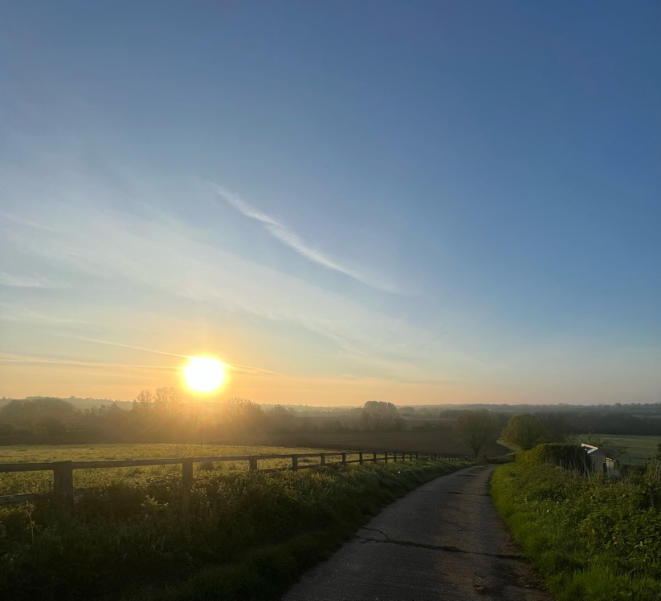

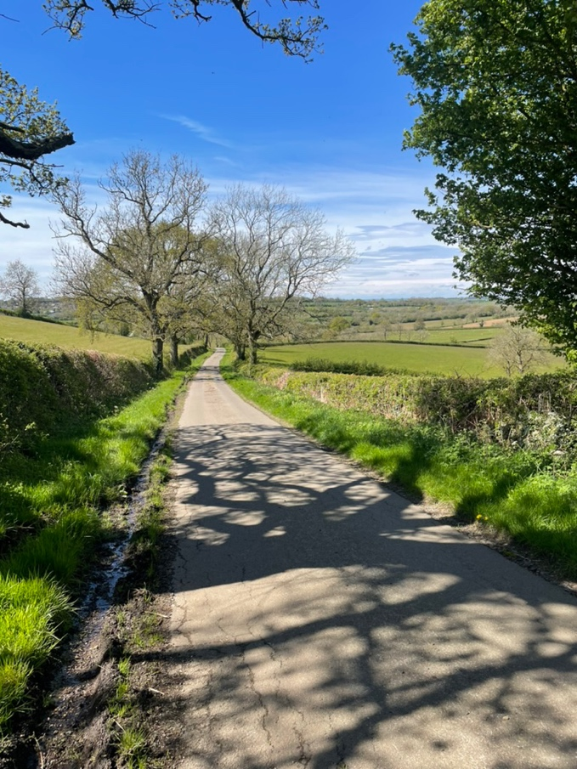
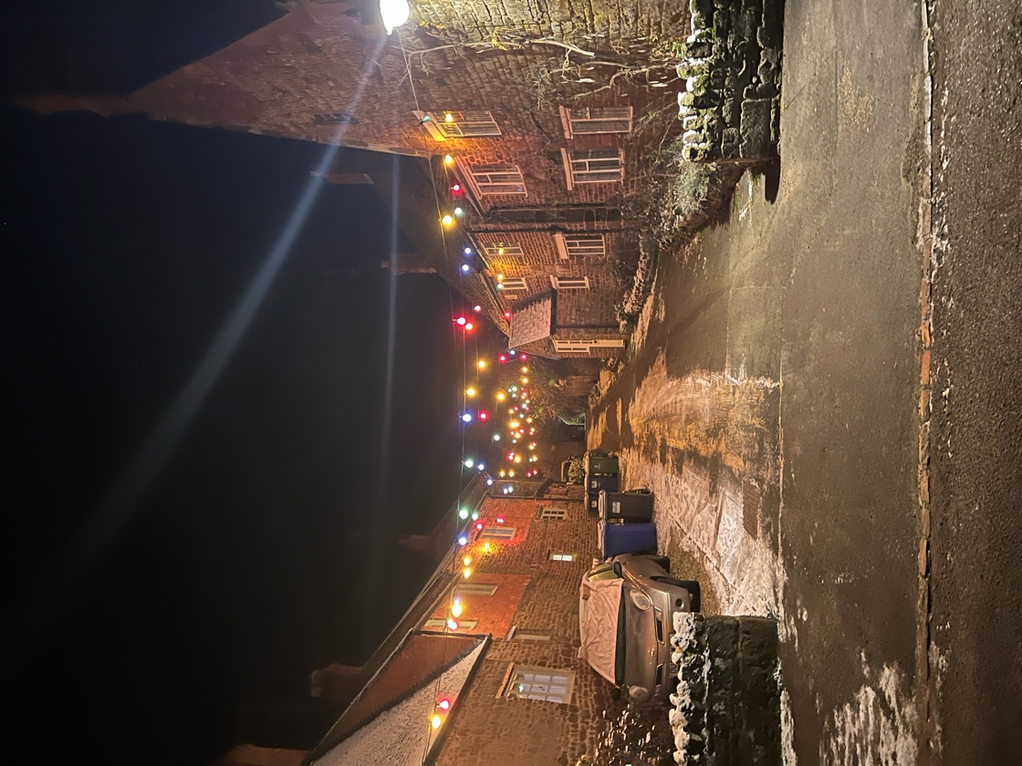



Welcome to Eydon

Table of Contents
Medical 3
Doctors 3
Pharmacies 3
Accident & Emergency 3
Police and Crime 3
Veterinary Services 4
Post Office 4
Banks 4
Churches 4
Convenience Stores 5
Coffee shops 5
Pubs and Restaurants 6
Takeaways 6
Utilities 7
Electricity 7
Water 7
Telephone 7
Broadband 7
Oil 7
Coal and Logs 7
Transport 8
Bus Services to Daventry and/or Banbury 8
Village Organisations 8
Eydon Community Sports Field 8
Eydon Village Hall 8
Eydon Village News 9
Eydon Ladies 9
Eydon Players Amateur Dramatic Society 9
Eydon Mummers 9
Eydon Cricket Club 10
Eydon Educational Trust 10
Eydon Parish Council 10
West Northamptonshire Council 11
Waste and Recycling 11

Medical
In case of emergency call 999
Non-emergencies call 111 or online https://111.nhs.uk or through the NHS App
Please note there are defibrillators located to the front of the village hall and the sports field pavilion.

Doctors
Byfield Medical Centre – Church Street, Byfield NN11 6XN
01327 265841
https://www.byfieldmedicalcentre.co.uk

Cropredy Surgery – Claydon Road, Cropredy OX17 1FB
01295 758372
https://www.cropredy-surgery.co.uk

You can use this link to find and register with a GP practice: https://www.nhs.uk/service-search/find-a-gp

Pharmacies
Popsons Pharmacy – 40 Station Road, Woodford Halse NN11 3RB | 01327 260393 | check online for opening times; https://popsonspharmacy.co.uk/

Middleton Cheney Pharmacy – 111 Main Road, Middleton Cheney OX17 2PD | 01295 710386 |check online for opening times; https://www.nhs.uk/services/pharmacy/middleton-cheney-pharmacy/FA449/contact-details-and-opening-times

Knights Banbury Pharmacy – Unit 2 Burchester Place, Grimsbury, Banbury OX16 3WT | 01295 278281 | check online for opening times;
https://www.knightspharmacy.co.uk/store/knights-banbury-pharmacy/

Boots Daventry Pharmacy – The Health Centre, Danetre Hospital, London Road, Daventry NN11 4DY | 01327 702353|Opening Times; Monday to Friday 09:00 am to 18:00 / Saturday 8:30 am to 12:30 pm / Sunday - closed

Accident & Emergency
Horton General Hospital – Oxford Road, Banbury OX16 9AL
Northampton General Hospital – Cliftonville, Northampton NN1 5BD

Police and Crime
In case of emergency call 999
Non-emergencies call 101 or online https://www.police.uk/pu/contact-us/
Crimestoppers 0800 555 111

Veterinary Services
West Bar Veterinary Surgery – 19 West Bar, Banbury OX16 9SA/16 Station Road, Woodford Halse NN1 3RB
01295 262332 (24 hours) | Open 16:00 to 18:00 (Woodford); other times for their other surgeries
https://www.westbarvets.co.uk

Avonvale Veterinary Centres – 4 The Cobalt Centre, Southam CV47 0FD
01926 812826 | Open Mon - Fri: 8:30 to 18:30 Sat: 8:30 to 12:30
https://www.avonvets.co.uk

Towcester Veterinary Centre – Burcote Road, Towcester NN12 6JW
01327 350239 | Open Mon - Fri: 8:30 to 17:00 Sat: 9:00 to 12:00
https://towcester-vets.co.uk

Post Office
Woodford (Popsons Pharmacy) – see above

Byfield (Co-op) - 29 High Street, Byfield NN11 6XQ
01327 263975 | https://www.postoffice.co.uk/branch-finder/2882264/byfield?campaignid=gmb%7Ebf%7E2882264%7Egoogle%7Ena%7E05022025&y_source=1_NjI0OTQ2NjItNzE1LWxvY2F0aW9uLndlYnNpdGU%

Sulgrave (Sulgrave Village Shop) – Magpie Road, Sulgrave OX17 2RT
01295 760066 | Open Mon – Fri 09:00 to 13:00

Banks
Lloyds Bank (Daventry) - 18 High Street, Daventry NN11 4HT
Open Mon – Fri 09:00 to 15:30 Sat 09:00 to 13:00

Nationwide (Daventry) - 24 High Street, Daventry NN11 4HU
0345 2660395 | Open Mon – Fri (exc. Weds) 09:00 to 16:30 Weds 10:00 to 16:30 Sat 09:00 to 12:00

HSBC (Banbury) - 17 Market Place, Banbury OX16 5ED
Open Mon – Fri 09:30 to 16:30 Sat 09:30 to 13:00

Churches
St. Nicholas Church, Eydon
Rector: Rev. Clare Glover | The Rectory, Church Street, Byfield | 01327 260204 | revclare@icloud.com
Churchwarden: Sue Yates |59 High Street, Eydon | 01327 260503

The usual pattern of Services:
First Sunday of the month - a non-communion Family Service at 10.30am
Second Sunday - Parish Communion at 9.00am
Third Sunday - All Age Communion at 9.00am
Fourth Sunday - Holy Communion (1662 Book of Common Prayer) at 9.00am
On a Fifth Sunday there is a Benefice Communion at 10.00am in one of the five villages
in the benefice (Aston-le-Walls; Boddington; Byfield; Eydon or Woodford Halse)

See Notice Boards, Eydon Village News or visit www.achurchnearyou.com/eydon

Convenience Stores
Dodds Manor Farm Shop - 22 High Street, Eydon NN11 3PP
01327 264452 | Open Thur – Sat 09:30 to 15:00
https://doddsmanorfarm.co.uk

Oboe Fine Wine Shop and Bar – High Street, Eydon NN11 3PP
01327 262383/07773 381745 | sales@oboefinewine.co.uk | Open Tue to Sun (See website for times)
https://oboefinewine.co.uk

Co-op Woodford - Phipps Rd, Woodford Halse NN11 3TW
Open Mon – Sun 06:00 to 22:00

Co-op Byfield - 29 High Street, Byfield NN11 6XQ
Open Mon – Sun 06:00 to 22:00

Sulgrave Village Shop- Magpie Road, Sulgrave OX17 2RT
01295 760066 | Open Mon 09:00 to 13:00 Tues – Fri 08:00 to 18:00 Sat 08:30 to 15:00 Sun 09:00 to 12:00

Mumford Butchers - High St, Culworth OX17 2BD
01295 760212 or 07831 556330 | Open Mon 08:00 to 12:00 Tues – Weds 08:00 to 11:00 Thurs – Fri 08:00 to 15:00 at 08:00 to 12:00
Note they also have a van which visits the village on a Wednesday.

Coffee shops
The Forge – High Street, Culworth OX17 2AZ
01295 768356 | Open Mon – Fri 08:45 to 16:00 Sat 09:00 to 16:00 Sun 09:00 to 15:00
https://www.forgecoffee.co.uk

Dodds Manor Farm Shop – as above
Takeaway

Pubs and Restaurants
The Royal Oak – 6 Lime Avenue, Eydon NN11 3PG
01327 640025 | info@theroyaloakineydon.co.uk | Tues - Wed: 17:00 – 22:00,
Thurs - Sat: 12:00 – 22:00, Sun: 12:00 – 16:00
https://theroyaloakateydon.co.uk

The Red Lion – High Street, Culworth OX17 2BD
01295 760050 | See their website for up to date opening times
https://www.theredlionculworth.co.uk

The Three Conies – Banbury Lane, Thorpe Mandeville OX17 2EX
01295 710431 | bookings@thethreeconnies.com
See their website for up to date opening times
https://www.thethreeconies.com

Takeaways
Fish and Chips (Howe & Co)
A mobile chip van calls on a Monday evening stopping in Manitoba and Lime Avenue by the pub around 8-8.45pm. You can pre-order, before 15:00 on 07395 833447 and track the van (Van 10) on www.howeandcofishandchips.co.uk

Woodford Kitchen - Unit 8, Great Central way, Woodford Halse NN11 3DP
07732 748900 | Mon-Thurs 0800 to 2030, Fri 0800 to 2100, Sat 1000 to 2100
Wide variety including fish and chips, pies, pizza, jacket potato and specials. You can collect or they can deliver.

Woodford Tandoori Cottage – 10 Station Road, Woodford Halse NN11 3RB
01327 261591 | Open 7 days (see website for times)
https://woodfordtandooricottage.com
Indian cuisine. You can collect or they can deliver.

Hot Panda - 30 Station Rd, Woodford Halse, Daventry NN11 3RB
01327 261518 | Open every day except Tuesday (see website for times)
https://www.hotpanda.co.uk
Chinese/Oriental cuisine. You can collect or they can deliver.

Forge Coffee in Culworth – see above
They often have food trucks in the evenings, please see their social media for details.

Utilities

Electricity
Power loss / Emergency (24 hour): 0800 056 8090
General enquiries (Central Networks): 0800 096 3080

Water
Anglian Water
Report an issue on 03457 145 145 or
https://www.anglianwater.co.uk

Telephone
There is a traditional red public phone box at the northern end of the High Street close to the junction with Hill View and Preston Road.

Broadband
Gigaclear offer fast fibre to the property internet. You can find out more and sign up via their website https://gigaclear.com
You can of course also use alterative providers eg. BT, sky etc.

Oil
You can use online price comparison tools (Boiler Juice, Homefuels direct etc) although deliveries in the village often include Certas, Watsons and Vale of Red Horse Fuels (amongst others).

YOBCO - Tel 01788 824236 | https://yobco.co.uk/

Gas/Coal and Logs
Leadbeater services – Blackbird Hill Farm, Eydon NN11 3QF
01295 760562 | leadserv@hotmail.co.uk
https://leadbeaterservices.co.uk

M. Davies Ltd - Badby Lane, Staverton NN11 6DE
01327 872877 | enquiries@mdaviesltd.co.uk
https://www.mdaviesltd.co.uk

K.G.Smith & Son - 11 Forest Road, Hartwell NN7 2HF
0808 1641079 | info@coalmerchantsuk.co.uk
https://www.coalmerchantsuk.co.uk

Transport

Bus Services to Daventry and/or Banbury
Stagecoach run a bus route (200) between Daventry and Banbury which stops at both Woodford Halse and Byfield. This runs Monday to Friday, as well as Saturday with a slightly altered timetable. You can find out more, including the full timetable, on their website https://www.stagecoachbus.com

Eydon is serviced by Ability for travel to Banbury. This is a subscription-based service and must be booked in advance. It operates on a Monday and a Thursday. For details or to register ring 01327 604123 or visit the website at www.abilitycic.org.uk

Woodford and Byfield are also served by Ability. This runs to Daventry. (Details as above)

Village Organisations

Eydon Community Sports Field
(Registered Charity No. 1125652)
Eydon Community Sports Field (ECSF), which is between the cemetery and the Old Rectory on the Culworth Road, is a sports facility which, since 2005, has been owned and available for use by the whole community and its visitors. It is predominantly a grass field with a cricket pavilion, toilet, play space, an equipped play area, multi-use games area, seating and cricket nets and is currently used for cricket, football, athletics & sports zone activities. In addition, there is an informal play space and an outdoor leisure area. During the cricket season the field is used on some Sundays by the Cricket Club for matches. There are football
nets available for children to use at any time. The field is used as a focal point for
community activities such as the Fete and charity running events. The play area for young children was installed early in 2008 and a multi-use games area, used for 5 aside football, basketball, netball and cricket, was constructed in 2009.
You can get more info on the Parish Council Website: https://eydonparish.gov.uk/organisations/eydon-community-sports-field
For further details, please contact Barry McRoberts on 01327 261570 or email: ecsf@eydon-village.co.uk

Eydon Village Hall
(Registered Charity No 1125650)
The Village Hall, situated on the High Street serves a valuable purpose as a meeting place for
the various village organisations and is also used throughout the year by many residents for
private functions.
The Hall is run by a committee made up of representatives from the organisations that use the Hall and other volunteers. The hall is maintained by revenue from hire charges, the annual village fete (shared with the church) and other fundraising events. Committee members and, where necessary, contracted tradesmen carry out maintenance of the hall. In addition, some village residents have given freely of their time and expertise to carry out valuable maintenance work for which the committee are very grateful. The Hall is available for hire for private or public functions. An alcohol license is available.
You can find out more info on the Parish Council Website: https://eydonparish.gov.uk/organisations/eydon-village-hall
Bookings: evh@eydon-village.co.uk

Eydon Village News
Eydon Village News, which is funded by the Parish Council, is a monthly newsletter and source of useful village news and information. After printing, it is distributed around the village by volunteers who in all weathers walk round to deliver the newsletters to your door towards the end of each month. You can also get a digital copy on the Parish Council Website or by requesting via email. If you would like to submit any news items or anything that may be of interest to the local population, please email to: evn@eydonparish.gov.uk

Eydon Ladies
Eydon Ladies meet on the 3rd Wednesday of every month and ladies from Eydon and surrounding villages are welcome. The meetings are usually at 7.30pm in Eydon Village Hall with some open meetings when non-members are welcome (including men!).
A varied programme is arranged each year with speakers, demonstrations and events to suit all tastes and interests. More info can be found on the Parish Council Website: https://eydonparish.gov.uk/organisations/eydon-ladies
Contact: Carrie Bedford – Chairperson 01327 262706
Ruth Kukla – Treasurer 01327 264109
Email: eydonladies@eydon-village.co.uk
Facebook: https://www.facebook.com/profile.php?id=100070704980730

Eydon Players Amateur Dramatic Society
Founded in 1989 and based at the Village Hall in the High Street, Eydon Players regularly provides the village with live entertainment. There are usually two public productions each year; an adult-orientated Spring production and a pantomime during the winter months. These are well supported by the village, the pantomime being very popular with families. Rehearsals usually take place at the Village Hall on Monday and Wednesday evenings.
Drama apart, the Eydon Players also support village fetes and children’s charities and there is an active social side to the society. Regular annual events are a members’ fund-raising/social evening, a dinner in January/February, a Garden Party in July and a barbecue in August and these are open to guests and prospective members. Visits are also made to other groups’ productions, for skills development and to other events of interest.
More info can be found on their website: http://eydonplayers.co.uk

Eydon Mummers
Eydon Mummers was formed at the end on 1991 by a group of villagers and friends, when a copy of the traditional Eydon Mummers Play became available. Since that time they have revived the tradition of sudden, largely unannounced (and usually under-rehearsed) performances of the Eydon and other Mumming plays at pubs and venues around the village at Christmas time, collecting money for a different charity each year.
In recent years the Mummers have raised money for Kathryn House Hospice for sick children; research into Crohn’s Disease; the causes of Cot Deaths; support for the international development agency, Intermediate Technology, and other good causes.
You can find out more on the Parish Council Website https://eydonparish.gov.uk/organisations/eydon-mummers or by contacting Ron Shuttleworth on 01203 676 721

Eydon Cricket Club
Eydon has a Cricket Club based at the Sports Field and has a competitive season of Sunday cricket with some two dozen matches booked each season with at least half of them played ‘at home’. Details of the matches are usually available in The Eydon Village News. You can also find more info on the Parish Council Website: https://eydonparish.gov.uk/organisations/eydoncricketclub
Or by contacting Simon Cann, Eydon Cricket Club Secretary: Email – si.cann@outlook.com

EYDON FIRST WEDNESDAY CLUB
We meet on the first Wednesday of every month in the village hall at 2.30pm and the club is open to anyone over 60. Subscription is £15 a year with any visitors being charged £2.50 a visit. Our membership continues to grow and we now have around 40 members. The programme for the year usually includes 7 interesting speakers on a variety of topics, a coach outing, a garden party and a festive luncheon after Christmas. At each monthly meeting we have a stall selling various useful items, a raffle and we conclude with tea and biscuits. The Club has an enthusiastic committee of 6 people who make it all possible.

Contact Richard Forsyth at randjforsyth@gmail.com or on 01327 264 235

Eydon Educational Trust
(Registered Charity No 309866)
The trust was set up in the village in 1985 and has an annual income of approximately £350
which can be used to promote the education of young people under the age of 25. They, or their parents, must be residents of Eydon who are in need of financial assistance towards
educational fees, expenses, scholarships etc. whether in primary, secondary or further
education. This can also include educational travel or assistance with the purchase of special
clothing, tools or instruments in readiness to enter a trade or profession upon leaving their place of education. The Trustees usually consider applications in the autumn at the commencement of the new
academic year and the closing date is publicised in Eydon Village News. If you wish to apply,
or find out more info, you can do so on the Parish Council Website: https://eydonparish.gov.uk/organisations/eydon-educational-trust-fund

Eydon Parish Council
Eydon Parish council meet monthly (second Tuesday of each month) (except August usually), to discuss Parish Council matters including general village maintenance, village projects and planning applications. The council is made up of seven councillors and a clerk. Members of the public are welcome to attend. You can visit the website for more info: https://eydonparish.gov.uk
Contact – Steve Fox (Clerk) clerk@EydonParish.Gov.Uk

West Northamptonshire Council
West Northamptonshire Council is the local council which is responsible for council tax, housing, highways, waste management, provision of local services and planning applications. You can find more info on their website: https://www.westnorthants.gov.uk

Waste and Recycling
There are waste and recycling centres reasonably local to the village, as detailed below. Please note from 3rd November you must book a slot in advance which you can do on their website. You can find out more on their website: https://www.westnorthants.gov.uk/bins-recycling-and-waste

TOWCESTER, Old Greens Norton Road (01327 353006) Closed Tuesdays & Wednesdays
DAVENTRY, Brown’s Road, off Staverton Road (01327 877539) – Open 7 days a week
NORTHAMPTON, Sixfields, Weedon Road (01604 582682) – Open 7 days a week

The Parish Council, so far as reasonably possible, has ensured that the contents of this
‘welcome pack’ are correct at the time of production and will not be held liable for any errors or omissions.

Last updated January 2026

